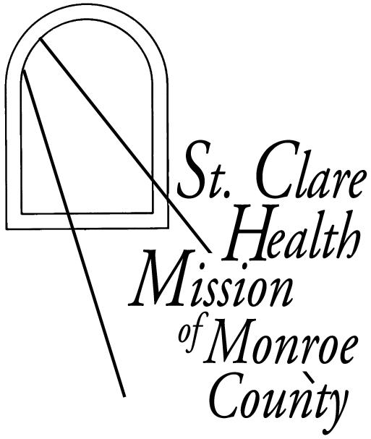
Return form to:
St. Clare Health Mission of Monroe County
310 West Main Street
Sparta, WI 54656
Ph: 608-366-5343
Fax: 608-366-1010

Thank you. Your gift will provide health care for Monroe County residents who have no health insurance and whose financial status prevents them from seeking medical care.

Yes, I want to support St. Clare Health Mission of Monroe County.
Checks payable to MCHS – FH St. Clare Health Mission Monroe County.
Contributions are fully tax-deductible to the extent permitted by law.

___$500 ___$250 ___ $100 ___$50 Other: $__________

This contribution is from:

Name(s): _________________________________________________
Address: __________________________________________________
City/ State/ Zip: _____________________________________________
Phone: ____________________________________________________
Email: ____________________________________________________

This is gift is ______in memory of
_____ in honor of

Send an acknowledgement of this gift (without reference to amount) to:

Name(s):

Address:

City/ State/ Zip:
_____ I am interested in learning more about volunteer opportunities to support St. Clare Health Mission of Monroe County.
_____ I would like to arrange for a presentation about the Health Mission for a Monroe County organization.
Please contact me.

